ECA0302 – SIGNALS AND SYSTEMS
NAME: RAGAVARSHINI R
REG.NO: 192512027
CO5 - EXP –(19,20)
To compute the Z-transform of a selected discrete-time signal using MATLAB.

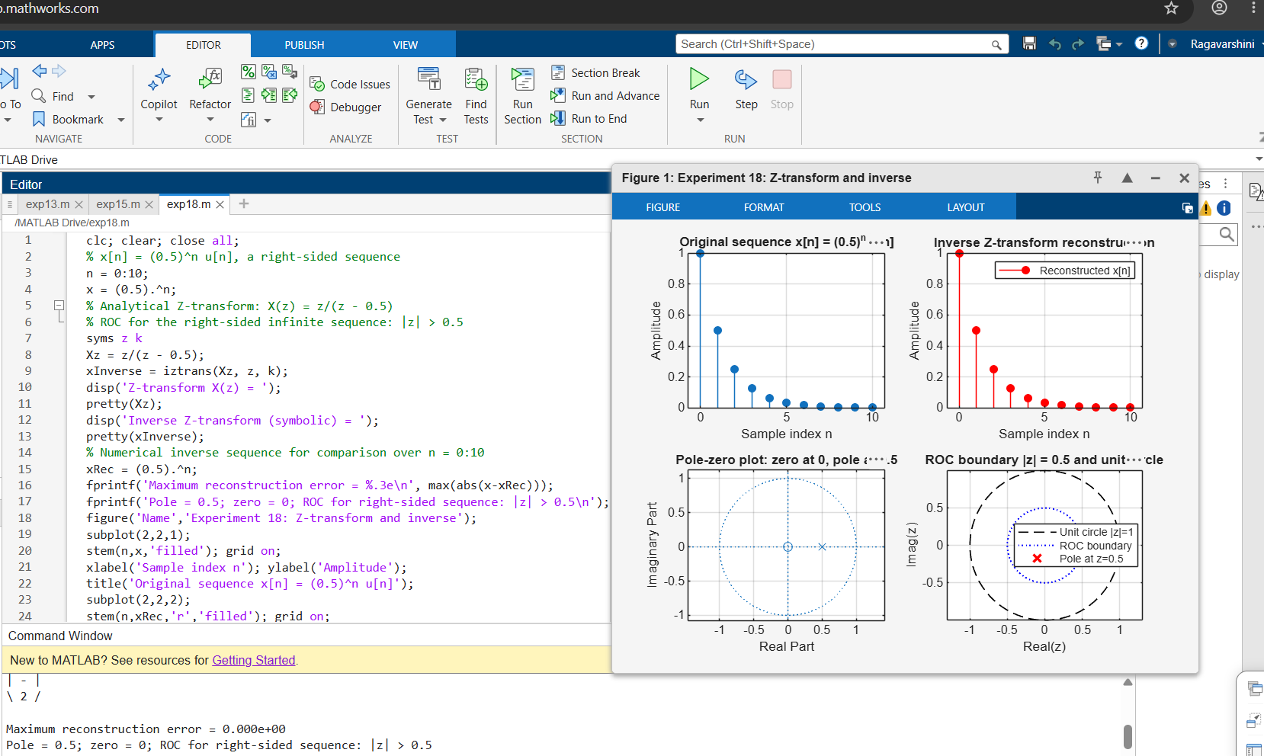
To generate a non-stationary signal containing time-varying frequency components and a transient.
